Guidelines for Preparing 2-Page Extended Abstracts and Full Papers for the Proceedings
First Author¹, Second Author² and Third Author^{2,*} ¹Institute1, Adress
²Institute2, Adress
*Corresponding author, E-Mail: abc@xyz.com

- Abstract
This section (Abstract) is a summary of this paper, and it will appear in a paper book of the Conference. It is important that the length of this section is contained in 10-14 rows and maximum 200 words.
Row5
Row6
Row7
Row8
Row9
Row10
Row11
Row12

Keywords: Enter a maximum of 5 keywords representing the main points of the document.

- Introduction
This document describes the format for the 2-page extended abstract to be presented in the Turkish Conference on Non-Destructive Testing to be held at Miracle Resort Hotel, Antalya / Turkiye, during May 08-10 2026. This document has been created in the required format. It can therefore be used as a template by simply typing over the existing contents of the file.
The extended abstracts are strictly limited to two pages, which will be published in the extended Abstract Volume for distribution among the congress participants, if accepted.
Conference information is available at this link: www.tcndt.com

A Sub Section Sample
Please note that the first paragraph of a section or subsection is indented. The first paragraph that follows a table, figure, equation etc. does not have an indent, either.
Subsequent paragraphs, however, are indented.

Sample Heading (Third Level). Only two levels of headings should be numbered. Lower level headings remain unnumbered; they are formatted as run-in headings.
Sample Heading (Forth Level). The contribution should contain no more than two levels of headings. The following Table 1 gives a summary of all heading levels.

Table 1. Table captions should be placed above the tables.
Heading level | Example | Font size and style
Title (centered) | Lecture Notes | 16 point, bold
1st-level heading | 1 Introduction | 14 point, bold
2nd-level heading | 2.1 Printing Area | 12 point, bold
Plain text | Displayed equations | 12 point

Displayed equations are centered and set on a separate line.
x + y = z (1)
Please try to avoid rasterized images for line-art diagrams and schemas. Whenever possible, use vector graphics instead (see Fig. 1).
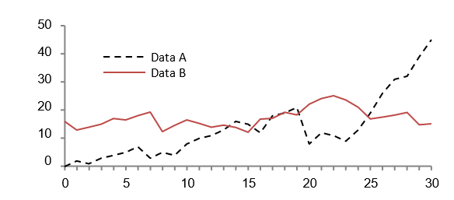
Fig. 1. A figure caption is always placed below the illustration. Short captions are centered, while long ones are justified. The macro button chooses the correct format automatically.

For citations of references, we prefer the use of square brackets and consecutive numbers. Citations using labels or the author/year convention are also acceptable. The following bibliography provides a sample reference list with entries for journal articles [1], an LNCS chapter [2], a book [3], proceedings without editors [4], as well as a URL [5].

References
- Author, F.: Article title. Journal 2(5), 99–110 (2016).
- Author, F., Author, S.: Title of a proceedings paper. In: Editor, F., Editor, S. (eds.) CONFERENCE 2016, LNCS, vol. 9999, pp. 1–13. Springer, Heidelberg (2016).
- Author, F., Author, S., Author, T.: Book title. 2nd edn. Publisher, Location (1999).
- Author, F.: Contribution title. In: 9th International Proceedings on Proceedings, pp. 1–2. Publisher, Location (2010).
- LNCS Homepage, http://www.springer.com/lncs, last accessed 2016/11/21.

